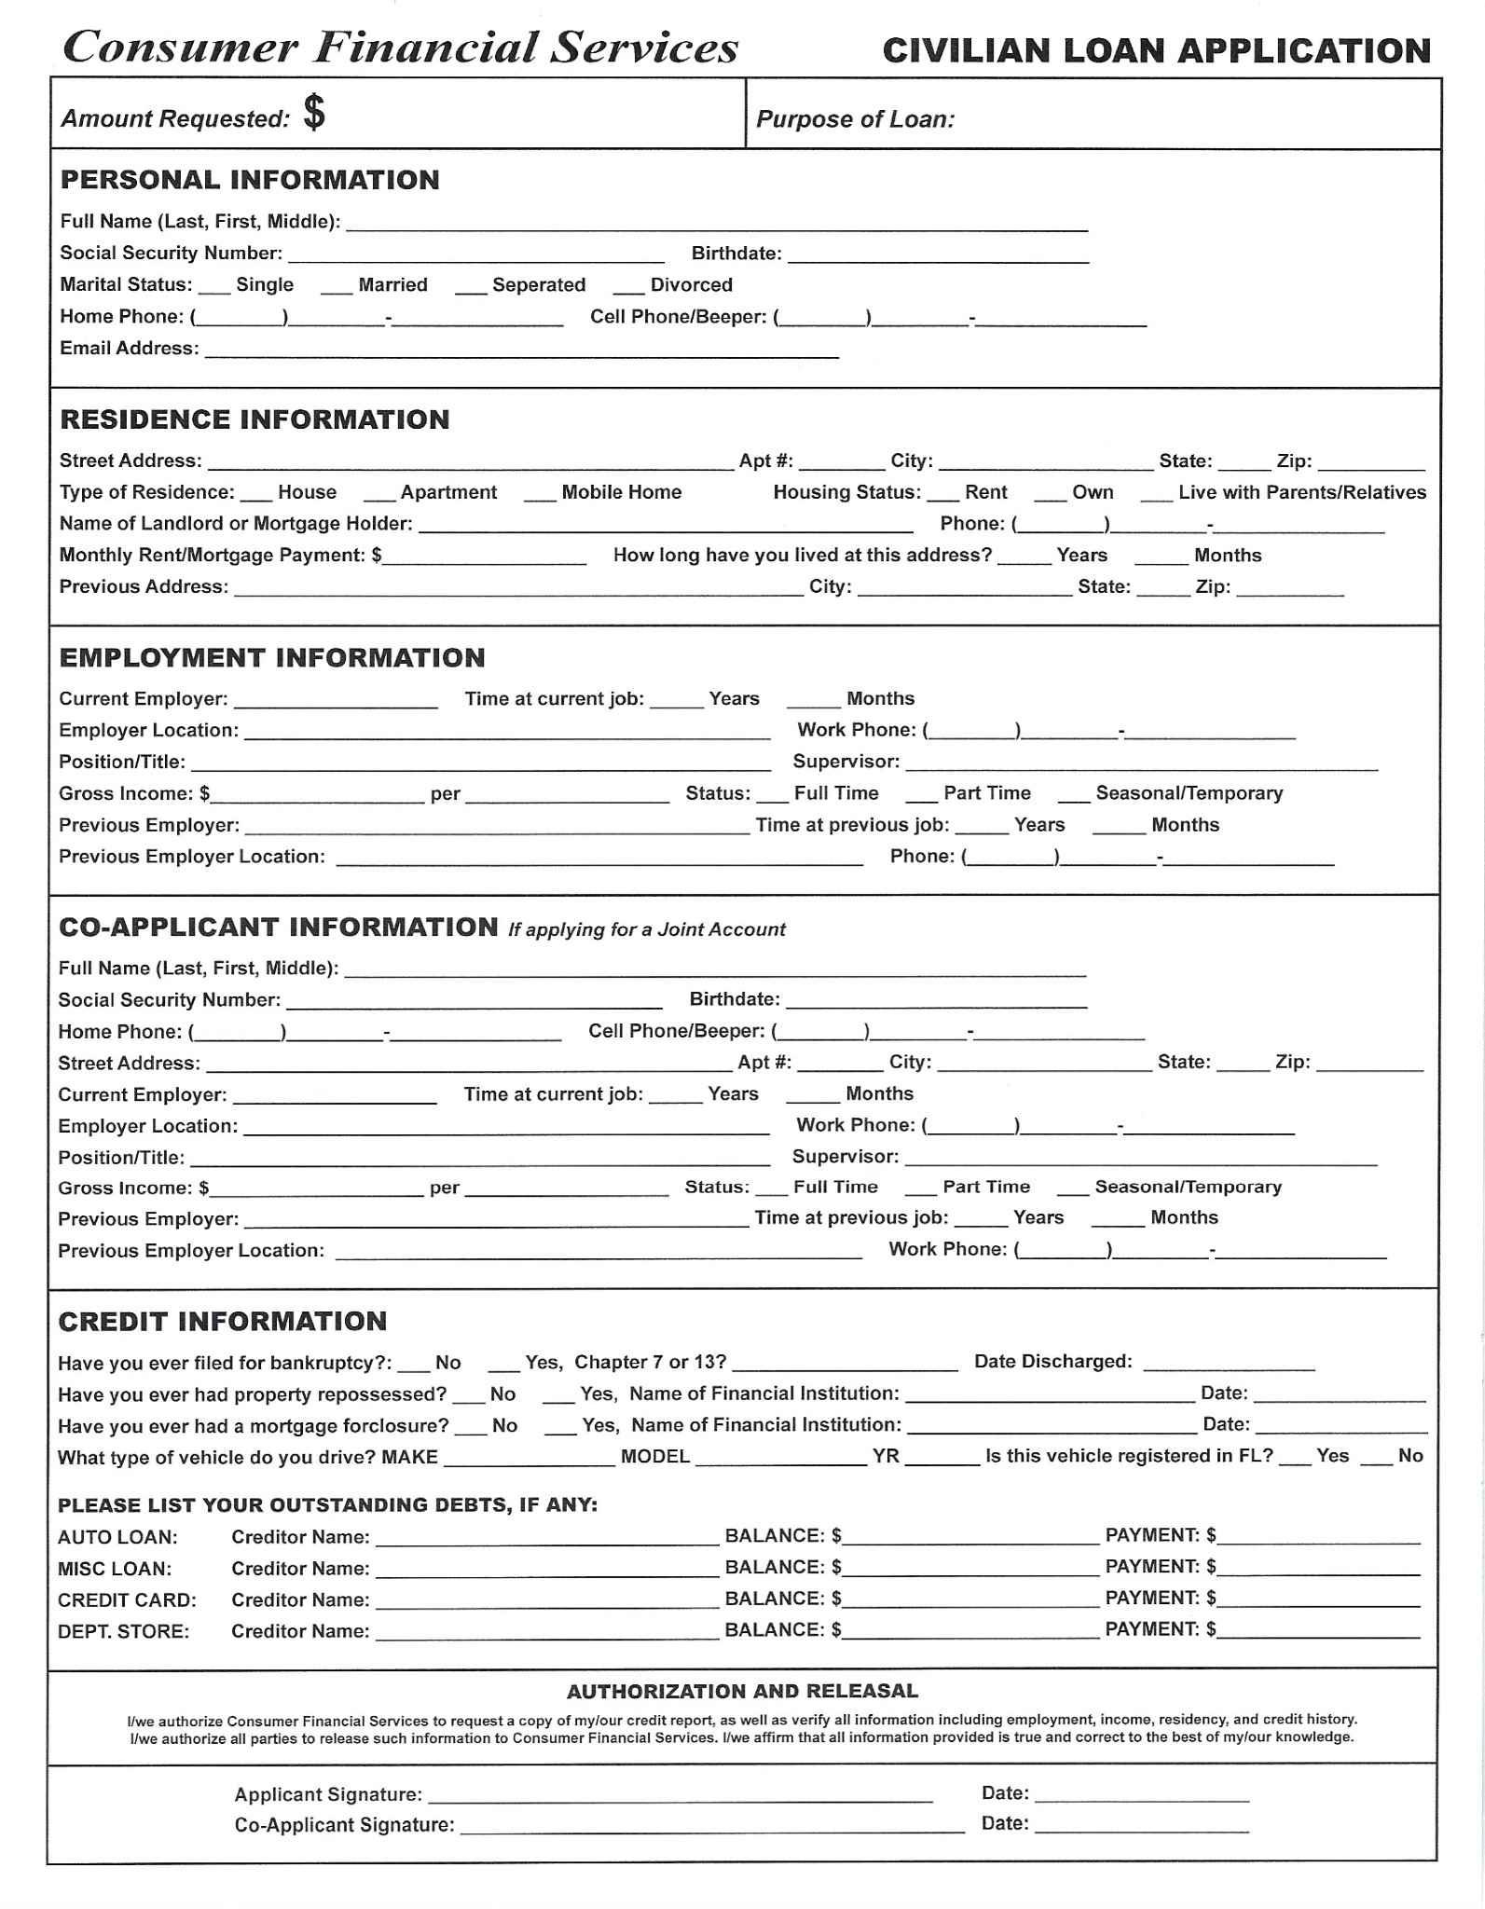

**How did you hear about us?** _____________________